Hi Everyone,

Welcome back to school after all this time! I’m sure things are very different at the moment, but we’ll soon get used to it.

Congratulations on being chosen as the Junior Road Safety Officers for your school. This is a great role where we can work together to highlight the road safety messages and work to keep everyone in your school community safer when they are out & about near the roads.

If you haven’t received your starter pack – get in touch and we’ll arrange to get one out to you asap.

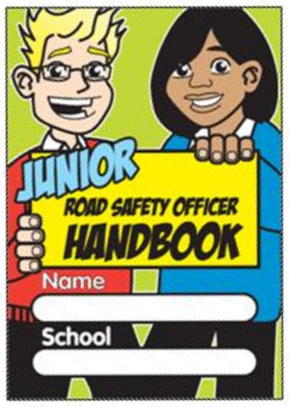

**We look forward to working with you this year and seeing the results of all your hard work!**

**JRSO Web Pages**

Take a look at [www.sysrp.co.uk](http://www.sysrp.co.uk).

You will find a section dedicated to the Junior Road Safety Officer scheme, with competition sheets to download, ideas and themes.



You will see in the handbook, that there is a road safety theme for each month – however don’t try and do everything – just pick out topics that you will enjoy or which you think may be a priority to your school.

**Jobs to do**

**Introduce yourselves** – an assembly is a good way to introduce yourselves & your role within the school

**Notice Board** –Ask for a notice board in school and put up your first display. Remember to update it regularly to keep it interesting.

**Plan** – what you are going to do next and throughout the year. What competitions will you run?

**Coming soon** –

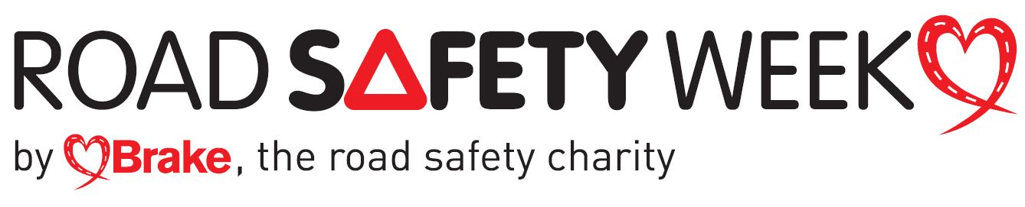

16 – 22 November 2020

Road Safety Week is the UK’s biggest road safety event

The theme for 2020: **No Need to Speed**

Check out their website <http://www.roadsafetyweek.org.uk/>

**October** – the topic is :

**Be Bright Be Seen**



This is a good topic to begin with and a good one to get everyone involved. How about having ‘a hi-viz’ day, when everyone wears something bright & reflective

**Keeping Active**

I’m sure lots of you have been out on your bikes or scooters during the ‘lockdown’

Would your school like to take part in the Bikeability training, which is offered **free** to Y6 pupils? This is great cycle training, giving you confidence and safety tips.

**Looking ahead…………..**

**November** – the topic is :

**The Green Cross Code &**

**Safer places to cross the road**

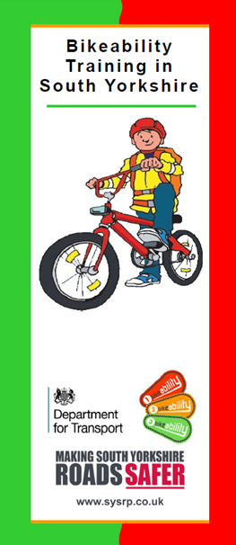

This is a good topic to demonstrate to the younger pupils in school during an assembly

If you would like this cycle training for your school - get in touch with us and we’ll let you have the contact details to book.

Remember – if you need any help, resources or information, just drop us an email and we’ll get back to you ASAP

Also remember don’t try to do too much. Keep it fun and interesting