

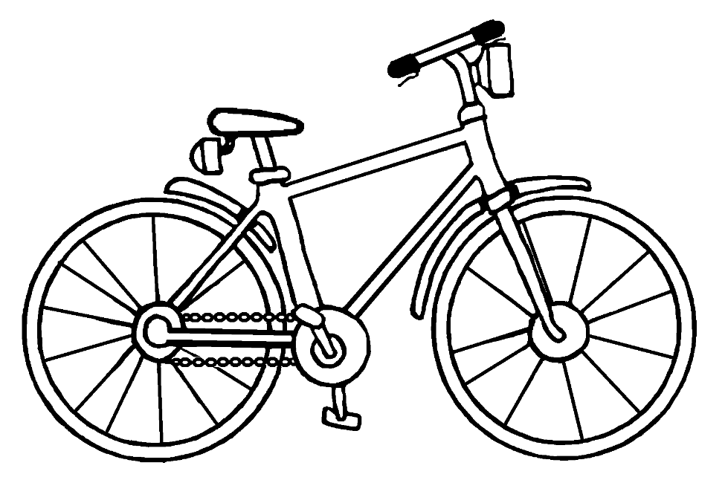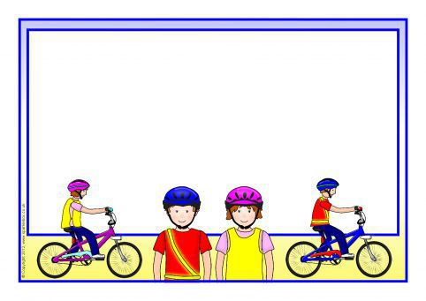

Following on from last month’s topic about **safer places to play** – the final topic in the handbook covers cycle and scooter safety, which is important at this time of year when more people are out and about on their bikes and scooters.

Now is a great time to inform the children in your school about playing safer on bikes and scooters and in fact, all things with wheels.

As more children are likely to be outside playing at this time of year, it is important to reinforce all safety messages to keep your friends safe.

Show your fellow pupils how to look after their bikes/scooters and how to keep themselves safe on 2 wheels.

Does everyone know the ‘M Check’? Why are helmets important?

What 3 things would you check on your bike to make sure it is road worthy?

It’s as easy as……

1. A_________________________

2. B_________________________

3. C_________________________

1. Air
2. Brakes
3. Chain

Summertime & road safety



We know this year has been far from normal and it has been very difficult for our JRSOs, as it has been for us road safety officers……but I’m sure you have done your best to get the important road safety messages across to your friends in school.

Why not finish the year off with a flourish and choose a fun topic to deliver, where the whole school can get involved?

Summertime is always fun – but there are lots of safety messages to pass on to keep everyone safe.

**Dates for your diary**

* **6th UN Global Road Safety Week 17 – 23 May**

“Low speed streets save lives and are the heart of any community. 20 mph speed limits where people and traffic mix make for streets that are healthy, green and liveable”

* **Child safety week 1 – 6 June**

Child Safety Week raises awareness of the risks of child accidents and how they can be prevented.

* **Beat the Street Rotherham 14 April – 26 May**

A fun, free game for the community to see how far you can walk, run or cycle around your area

Earn as many points as possible for you and your team by walking, running, scooting, cycling or rolling between **Beat** Boxes

* **Beat the Street Sheffield 16 June – 28 July**
* **Beat the Street Barnsley 10 June - 22 July**

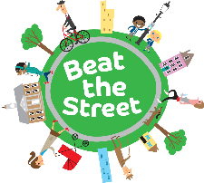

We hope you have enjoyed your ‘limited’ experience as a Junior Road Safety Officer,

and wish you a safe and happy future and lots more successes 