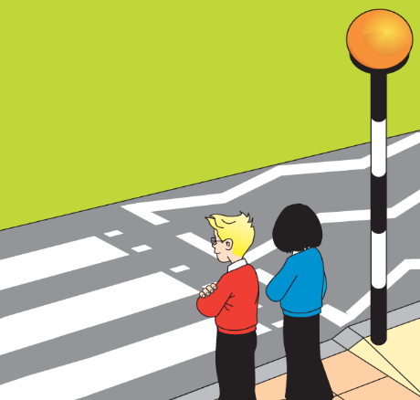

Remind everyone about Be Bright Be Seen,

to stay safe when out and about when it is dark – especially if they going out to celebrate Bonfire Night

Sometimes the roads are really busy and the only way to cross is by looking for somewhere safer to cross.

Can you identify and name some pedestrian crossings that you can use to cross the road safer?

**The Green Cross Code**

Hello JRSOs!

I hope you are enjoying your role as JRSO, and have lots of ideas for the future weeks in school.

Can you believe it is nearly Christmas?!

The 2 themes over the next 2 months are : the **Green Cross Code** and **Being careful with those Xmas gifts**.

You will have noticed that it is darker on your school journeys in the mornings and evenings. This may be a good time to remind people to “Be Bright, Be Seen”, as well as making sure they cross the road safely, without being distracted.

The green cross code is a set of instructions that help us cross the road safer.

Do you know what the green cross code is? What about your friends?

**Activities -** What could you do?

Update your notice board with new posters and info about safer places to cross.

Act out how to use the **Green Cross Code** in an assembly delivered in school.

Find out about the different types of pedestrian crossings. Does everyone know how to use them correctly?

Pedestrian Crossings

**Be careful with those gifts**



Christmas & New Year is a very exciting and busy time – with lots happening and lots of **distractions.**

Think about the presents that Father Christmas may leave on Christmas morning and how we can be safe with them.

For example : what safety messages do we need to pass on to children who get a new bike or scooter?

For example : what dangers can be caused by wearing headphones or using mobile phones when out & about?

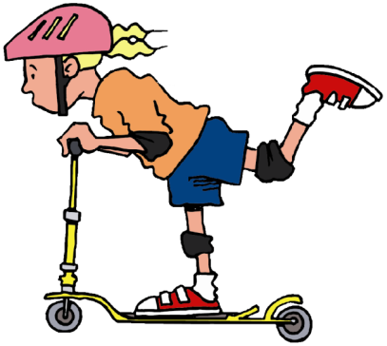

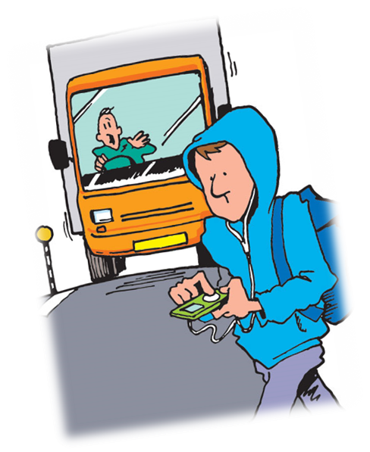

**Upcoming events**

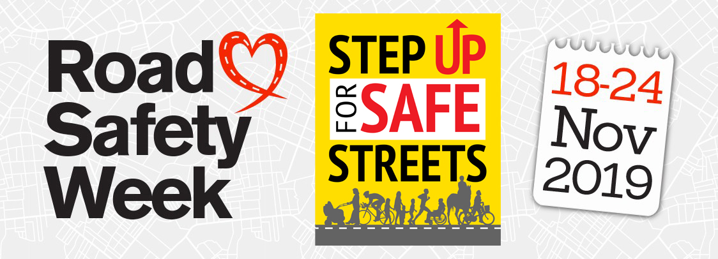

**18 – 24 Nov** – Road Safety Week

Road Safety Week is a yearly campaign run by BRAKE.

**2 Nov** – Locke Park Bonfire & Fireworks Spectacular

**3 Nov** – Bonfire Spectacular at Cannon Hall Farm

**1 Dec** – Santa’s Grotto opens in Alhambra

**7/8 & 14/15 & 21/22 Dec** – Father Christmas visits Cannon Hall Museum

**Coming up**……………The next topic in the handbook to think about, is seatbelts & child seats

**ALWAYS remember to STOP, LOOK & LISTEN when crossing the road**

Name: _____________________________ Age: ________________________________

Class: _____________________________

Send your coloured pictures in and you may see them in the next newsletter or on our website!