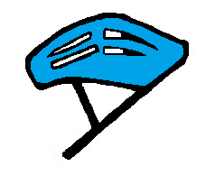

**Helmets are very important**

When June comes around it will be time to look at wrapping up as well…….your job is nearly complete.

All you need to do is place all the work that you have had chance to do, together in a folder labelled with your names and school. I will then arrange to come and collect this folder from you and leave your certificates.

Your folders will be entered into our JRSO competition so make sure your names are on them.

Hello JRSO!

I hope you had a lovely Easter and are all enjoying the lighter nights and the lovely sunshine (when it’s out) 

We have looked at several important road safety topics since September and now it’s our last one = **safer cycling and scootering.**

Now is a great time to talk to children in your school about playing safer on bikes and scooters and in fact, all things with wheels.

As more children are likely to be outside playing at this time of year, it is important to reinforce all safety messages to keep your friends safe.

**JRSO Contents**

Activities – what different activities can you get involved in to get your road safety messages out. Remember you can still look at past newsletters for ideas or use your own.

Recruitment – when June comes around, it will be a good time to start thinking about the next years JRSOs.

Finishing Off – all folders and handbooks should be put together by **Friday 19th June**.

Events – Look at some of the big campaigns we will be getting involved in.

**Did you know**…… that many children (and adults) do not wear a helmet? Wearing the correct size helmet in an accident could reduce head injuries by a whopping **85%!**

**Safety Equipment**

Is important and has been developed and made to keep you safer when you are out & about.

Look below at **all** the things that can help to keep you safe when you are out on your ‘wheels’.

They may even save your life!

**A helmet** – reduces head injuries

**Lights/reflectors** – so that you can be seen

**Hi Viz** – keeps you bright & easier to be seen

**Maintenance** – make sure your bike or scooter are in good working order and safe to ride

**Elbow & knee pads** – will give protection if you fall off

**Training** – makes sure you have good skills whilst riding

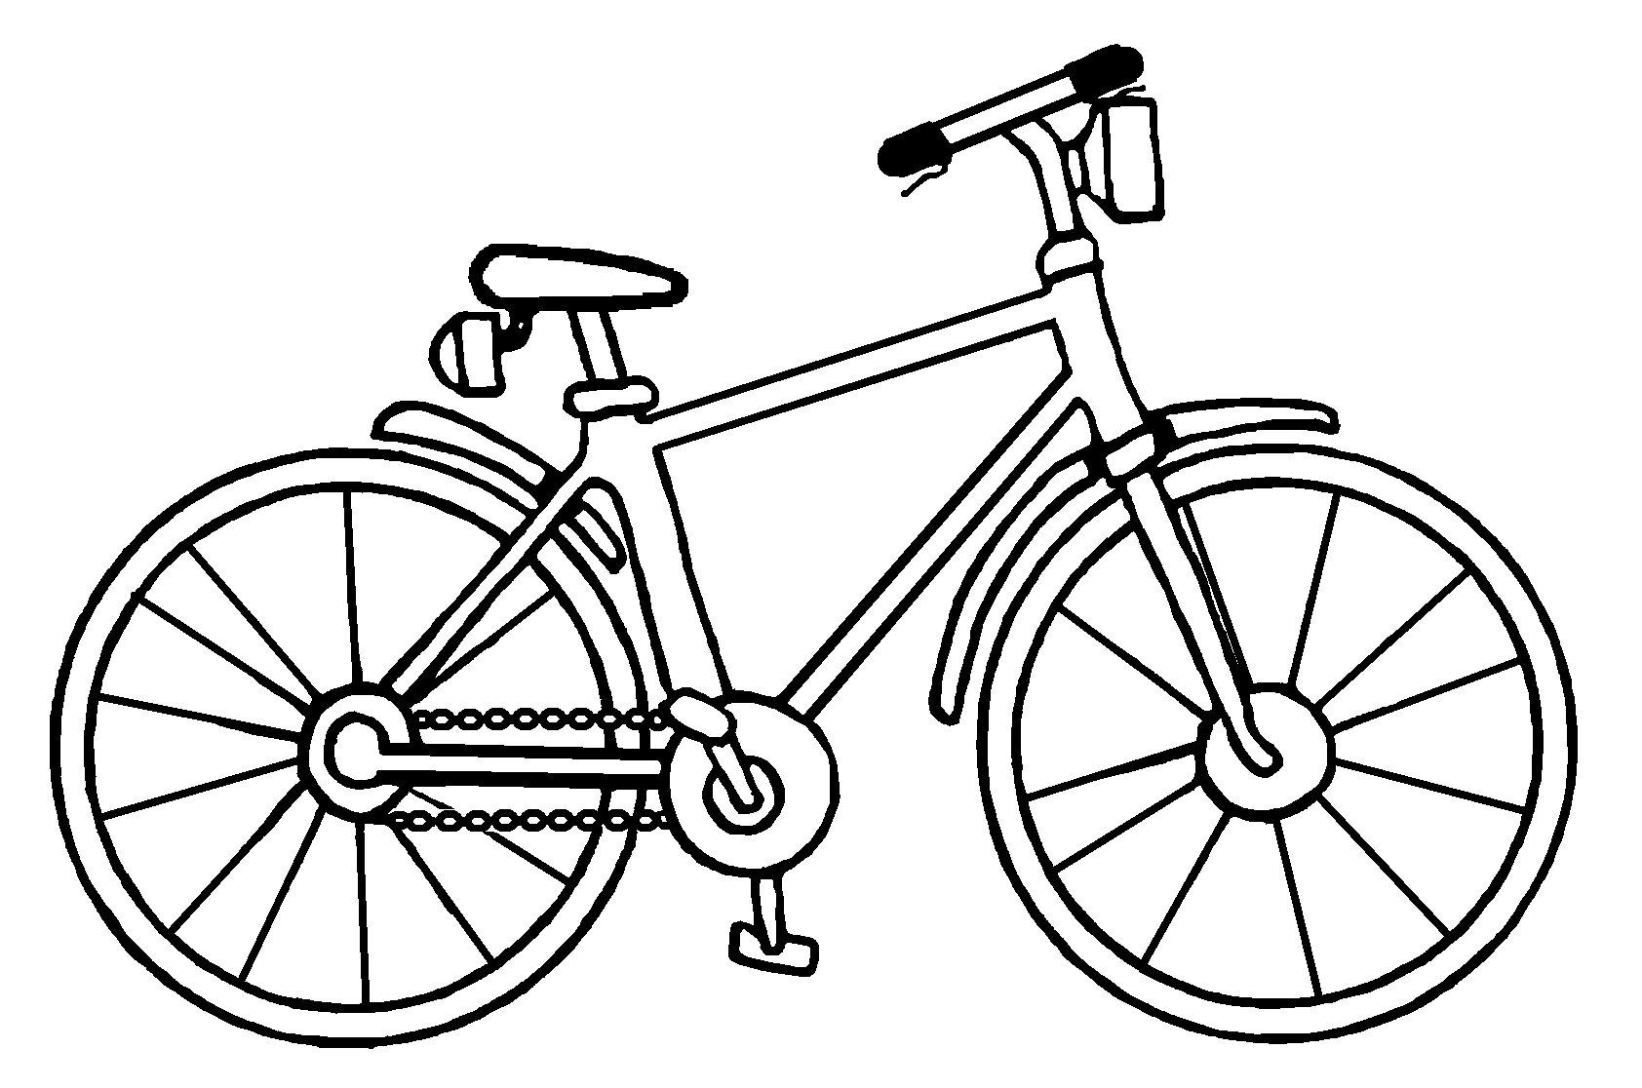

Cycle Maintenance

What 3 things would you check on your bike to make sure it is road worthy?

1. __________________________

2. __________________________

3. __________________________

The answers are on the website, with other important information that you can use.

**Finishing off and completing your folders**–from **Friday 19th June**, make sure all your work is put together in a folder so it can be entered into the JRSO end of year competition.

Make sure you have the following items in/on your folder:

* Your school name
* All the names of the JRSOs
* All the work that you have done during the year as part of the role

You can put your folder together however you want, maybe with dividers, split between themes for example. It is your work to show off.

**Remember:** it is not all about quantity. If you have not managed to get loads done, do not worry. Taking part is what matters and getting key road safety messages out in your school.



**Recruitment** – are you helping to choose next year’s JRSOs? Do you know

where to start?

There are lots of different ways, whether it is through the School Council, an

application form or if suitable children are nominated.

You can find a lot of information here on the website:

<http://sysrp.co.uk/junior_road_safety_officers/about/>

**Events for your diary :**

* 3 May – Barnsley leg of the Tour de Yorkshire including both women’s and men’s races
* 24 & 27 May – Schools Tour de Yorkshire
* 14 July – Barnsley Mayors Parade **TBC**
* 19 July – Barnsley Town Centre Cycle Race

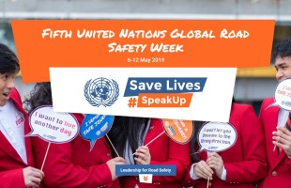

**Date : 6 – 12 May 2019**

**The United Nations Road Safety Week is here for its 5th year**

The aim this year is to highlight :

* the risks people face on their daily travels – “this is my journey”;
* the demands they generate based on these risks – “this is my demand”;
* the ways that forceful and compelling leaders can work with them to address these demands – “this is our solution”.

*\*curtesy of United Nations Global Road Safety Week*

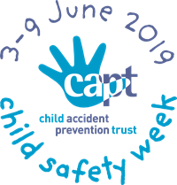

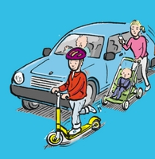

**Child Safety Week** is returning in June.

The theme this year is **Family life today: where’s the risk?**

Check out the website for more info : [www.capt.org.uk/child-safety-week](http://www.capt.org.uk/child-safety-week)